FULL STACK DEVELOPMENT PRACTICAL

To-Do List Web Application

1. Practical scenario
Develop a responsive To-Do List web application that allows users to manage everyday tasks. Users should be able to add tasks, mark them as completed, delete tasks, and filter tasks.
Use only HTML, CSS, Bootstrap, and JavaScript. No backend server or database is required.

2. Project structure
Create a folder named TodoList containing these three files:
- index.html – webpage structure
- style.css – custom styling
- script.js – JavaScript functionality
Use Bootstrap 5 through its CDN. Keep HTML, CSS, and JavaScript in separate files.

3. Practical tasks and marking scheme
Task 1: Create the page structure
Create a page containing a navigation bar, page heading, task input field, Add Task button, task list, task counter, filter buttons, and Clear Completed button.
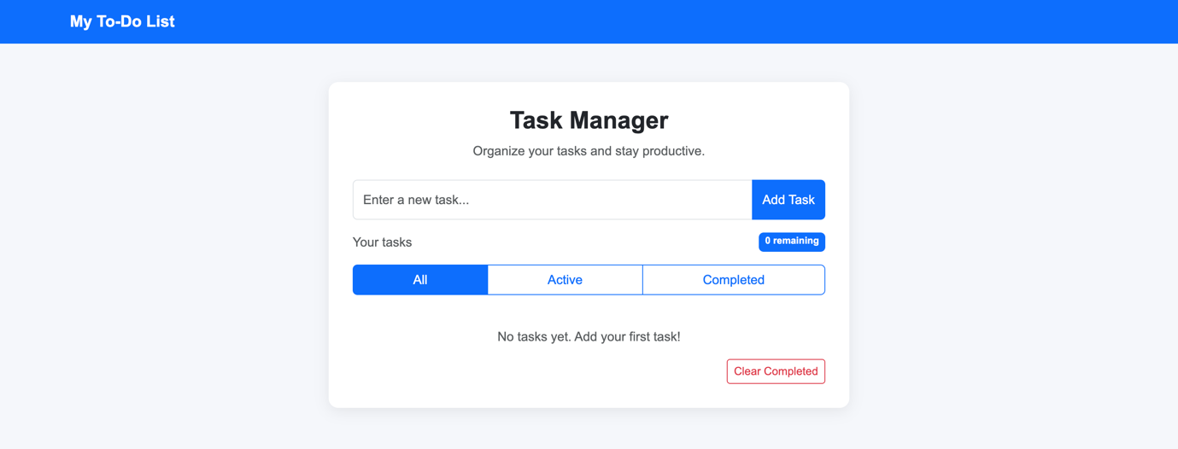
Task 2: Style the application
Use Bootstrap and custom CSS to create an attractive, responsive interface that works on desktop and mobile screens.

Task 3: Add tasks
Use JavaScript to add a new task when the user clicks Add Task. The task must appear without reloading the page. Clear the input field after a successful addition.
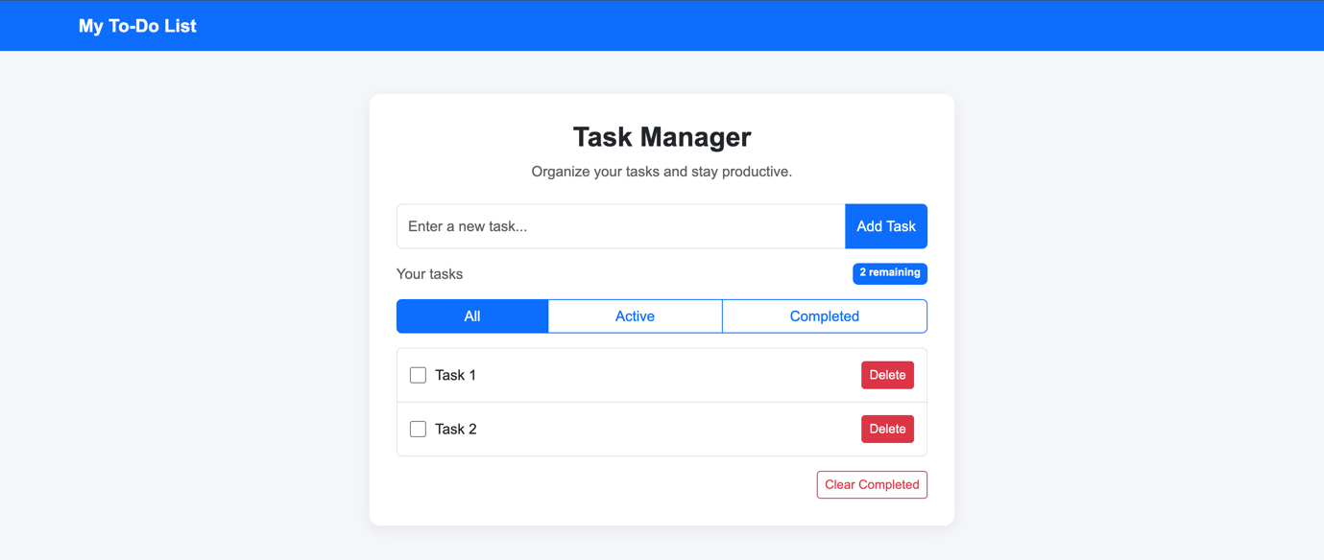
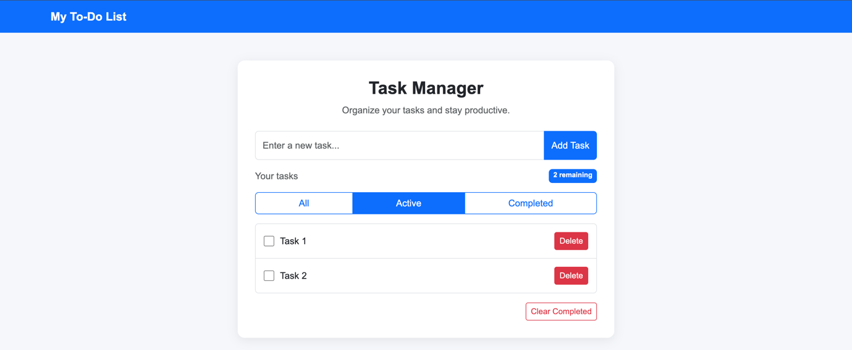

Task 4: Complete tasks
Provide a checkbox or equivalent control to mark tasks as completed. Users must also be able to mark completed tasks as active again. Completed tasks should have a different appearance.
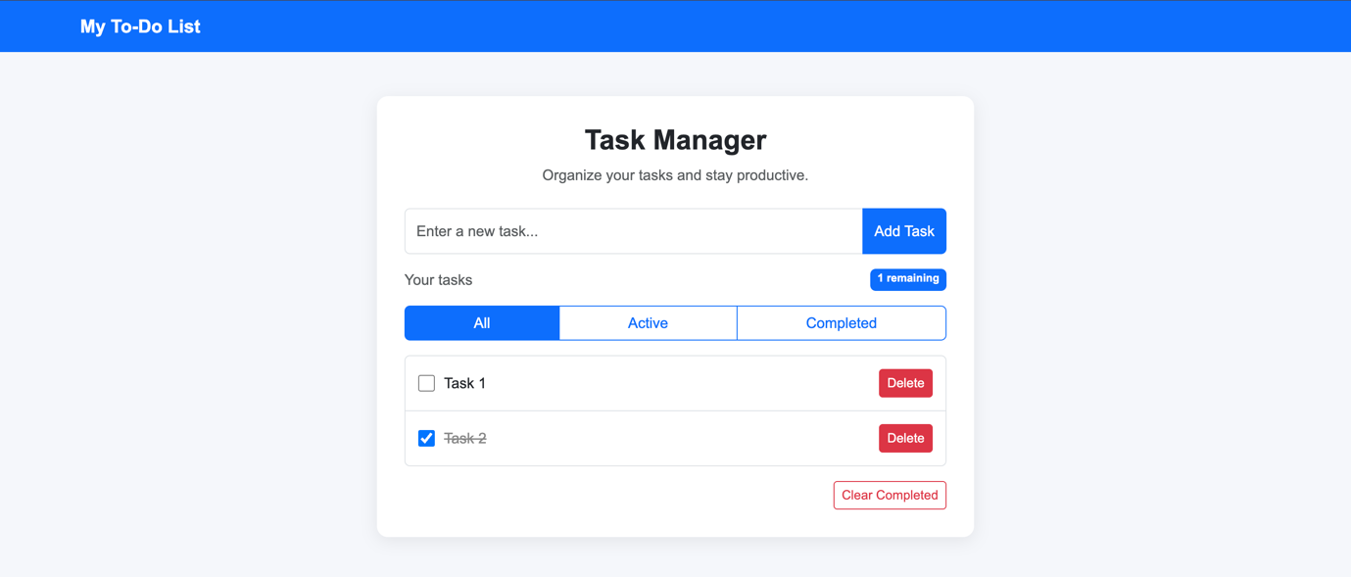
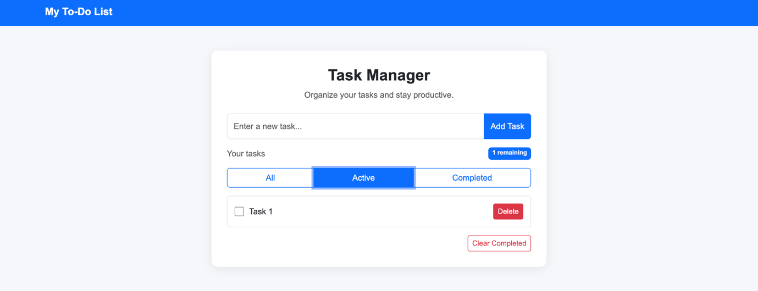
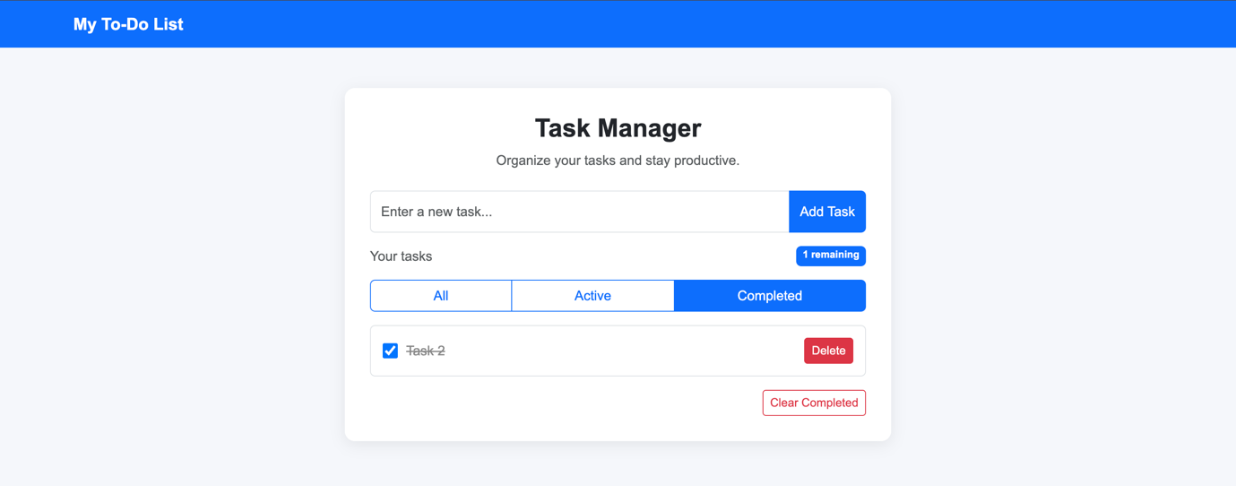
Task 5: Delete tasks
Provide a Delete button for each task. Clicking it should remove only the selected task.

Task 6: Validate user input
Prevent users from adding empty tasks or tasks containing only spaces. Display an appropriate error message.
Task 7: Filter tasks
Implement the following filters:
- All: Display every task.
- Active: Display only incomplete tasks.
- Completed: Display only completed tasks.
Task 8: Task counter and clearing completed tasks
Display the number of incomplete tasks. Implement a Clear Completed button that removes all completed tasks while keeping active tasks.

4. Optional challenge
Use JavaScript Local Storage to preserve tasks when the browser is refreshed. This is optional and is not required for the core assessment.

5. Testing checklist
Students should test each of the following before submission.
☐ Add a valid task.
☐ Attempt to add an empty task.
☐ Mark a task as completed and active again.
☐ Delete a selected task.
☐ Test all three filters.
☐ Check whether the task counter updates correctly.
☐ Clear completed tasks without deleting active tasks.
☐ Test the application on a narrow screen.
☐ If Local Storage is implemented, refresh the browser and check the saved tasks.

6. Submission instructions
- Create a GitHub repository named IndexNumber_Name_TodoList.
- Upload all project files, including index.html, style.css, and script.js, to the repository.
- Ensure the repository is accessible to the lecturer.
- Copy the GitHub repository URL and submit it through the designated submission platform.
- Test the application and ensure all required features work correctly before submission.

